Learn 4 –

* While we are applying such practical’s then stored image as well as code both should be stored in same DIRECTORY or drive
* In resizing of an image width can be increase as well as decrease the image size
* Here when we are using command for BLUR an image then we have to use only odd numbers in command, on using even numbers in command it will represents error as:-

“error: (-215:Assertion failed) ksize.width > 0 && ksize.width % 2 == 1 && ksize.height > 0 && ksize.height % 2 == 1 in function 'cv::createGaussianKernels' ”

* Here in BLUR image command on increasing value of odd number pair there is increment in BLURNESS of image
* In thresholding of an image there is changes in sharpness or thresholdness, on increasing the parameters

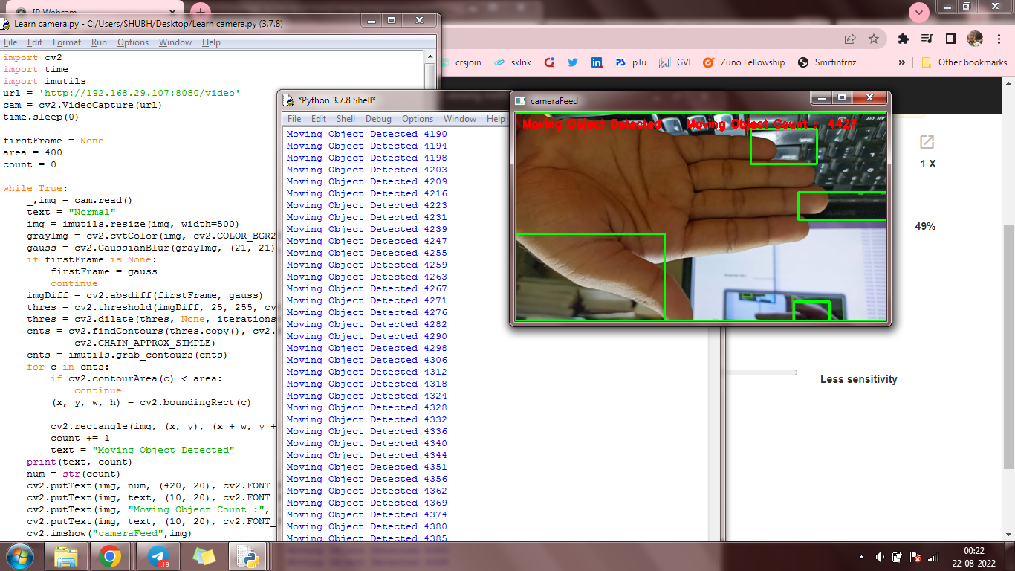

* In camera opening command when we initialize the camera then VideoCapture() command indicates that, in bracket number or any particular defined name will written which will indicate that “WHAT IS THE WAY FOR CAMERA USING”.
* Ex. (0):- Uses for opening laptop in-built camera,(1) :- Uses for opening any external cable connected camera,(ip):- Or any other name uses for opening any ip addressed entered camera or any other way of opening camera.
* In Camera command time.sleep(),uses for after how many seconds the camera will capture the image(Termination Process). In bracket we mention time in terms of seconds.
* (0,255,0) is a pattern of COLOR uses in codes which is format of,(BLUE,GREEN,RED) [B,G,R]